***SOFTWARE DESIGN DOCUMENT***

**1.0 Introduction**

The sole purpose of the software design document is to give a description of the Meezy Cutz appointment booking system. Topics included are:

* Class diagram
* User interface design
* Method/Operation specification
* Interaction diagrams
* Database design
* Test cases

All in all, this document should leave the reader with a clear understanding of how the use of the online appointment system works.

**1.1 Goals and objectives**

Overall goal of the project is to allow customers to create an online account so that they are able to make an appointment. After a customer books an appointment, they will have the ability to modify or cancel their appointment via the booking system.

**1.2 Statement of scope**

A description of the software is presented. Major inputs, processing functionality, and outputs are described without regard to implementation detail. **1.3 Software context**

The software is placed in a business or product line context. Strategic issues relevant to context are discussed. The intent is for the reader to understand the 'big picture'.

**1.4 Major constraints**

Any business or product line constraints that will impact he manner in which the software is to be specified, designed, implemented or tested are noted here.

**2.0 Data design**

A description of all data structures including internal, global, and temporary data structures.

**2.1 Internal software data structure**

Data structures that are passed among components the software are described.

**2.2 Global data structure**

Data structured that are available to major portions of the architecture are described.

**2.3 Temporary data structure**

Files created for interim use are described.

**2.4 Database descriptio**

Database(s) created as part of the application is(are) described.

**3.0 Architectural and component-level design**

A description of the program architecture is presented.

**3.1 Program Structure**

A detailed description the program structure chosen for the application is presented.

**3.1.1 Architecture diagram**

A pictorial representation of the architecture is presented.

**3.1.2 Alternatives**

A discussion of other architectural styles considered is presented. Reasons for the selection of the style presented in Section3.1.1 are provided.

**3.2 Description for Component n**

A detailed description of each software component contained within the architecture is presented. Section 3.2 is repeated for each of n components.

**3.2.1 Processing narrative (PSPEC) for component n**

A processing narrative for component n is presented.

**3.2.2 Component n interface description.**

A detailed description of the input and output interfaces for the component is presented.

**3.2.3 Sub-Component n.m processing detail**

A detailed algorithmic description for each sub-component within the component n is presented. Section 3.2.3 is repeated for each of the m sub-components of component n.

**3.2.3.1 Interface description**A description of sub-component m inputs and outputs is presented.

**3.2.3.2 Algorithmic model (e.g., PDL)**The pseudocode listing for sub-component m is presented.

**3.2.3.3 Restrictions/limitations**The external environment and/or infrastructure that must exist for sub-component m to operate correctly is provided.

**3.2.3.4 Local data structures**The data structures used within sub-component m are presented.

**3.2.3.5 Performance issues**Information on topics that may affect the run-time performance, security, or computational accuracy of this sub-component are presented.

**3.2.3.6 Design constraints**Attributes of the overall software design (including data structures, OS features, I/O, and interoperable systems) that constrain the design of this sub-component are presented.

**3.3 Software Interface Description**

The software's interface(s) to the outside world are described.

**3.3.1 External machine interfaces**

Interfaces to other machines (computers or devices) are described.

**3.3.2 External system interfaces**

Interfaces to other systems, products, or networks are described.

**3.3.3 Human interface**

An overview of any human interfaces to be designed for the software is presented. See Section 4.0 for additional detail.

**4.0 User interface design**

A description of the user interface design of the software is presented.

**4.1 Description of the user interface**

A detailed description of user interface including screen images or prototype is presented.

**4.1.1 Screen images**

Representation of the interface form the user's point of view.

**4.1.2 Objects and actions**

All screen objects and actions are identified.

**4.2 Interface design rules**

Conventions and standards used for designing/implementing the user interface are stated.

**4.3 Components available**

GUI components available for implementation are noted.

**4.4 UIDS description**

The user interface development system is described.

**5.0 Restrictions, limitations, and constraints**

Special design issues which impact the design or implementation of the software are noted here.

**6.0 Testing Issues**

Test strategy and preliminary test case specification are presented in this section.

**6.1 Classes of tests**

The types of tests to be conducted are specified, including as much detail as is possible at this stage. Emphasis here is on black-box and white-box testing.

**6.2 Expected software response**

The expected results from testing are specified.

**6.3 Performance bounds**

Special performance requirements are specified.

**6.4 Identification of critical components**

Those components that are critical and demand particular attention during testing are identified.

**7.0 Appendices**

Presents information that supplements the design specification.

**7.1 Requirements traceability matrix**

A matrix that traces stated components and data structures to software requirements is developed.

**7.2 Packaging and installation issues**

Special considerations for software packaging and installation are presented.

**7.3 Design metrics to be used**

A description of all design metrics to be used during the design activity is noted here.

**7.4 Supplementary information (as required)**

**Test Cases**

* What if the appointment is not successfully processed?
* What if the customer is unable to login to their account?
* What if confirmation email does not send to the Admin?
* What if the site is down and appointments are lost?
* What will the admin receive from the database after an appointment?
* What if the database shuts down and clients are unable to book?

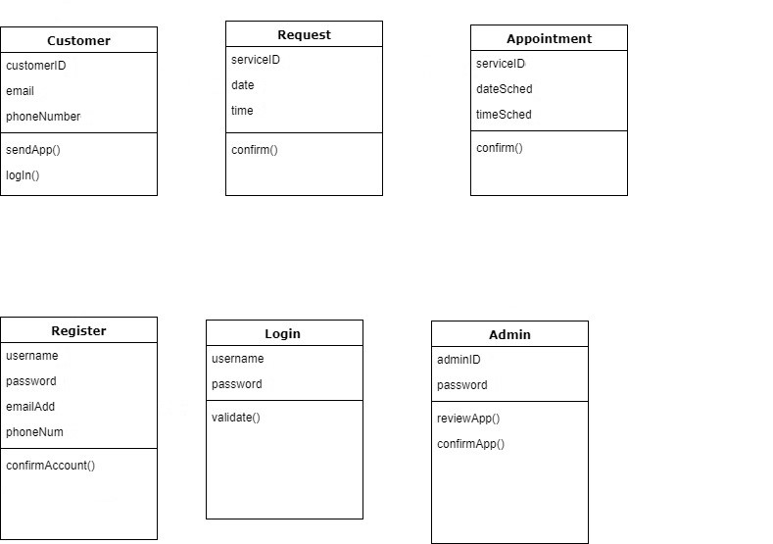

DD Template